|  |  |
| --- | --- |
| **Ex No: 9 Date:** | **ANALYZE DIFFERENT TYPES OF SERVERS USING WEBALIZER** |

**AIM:**

To analyze the different types of web logs using Webalizer tool.

**PROCEDURE**:

Step 1: Download Apache web server using- dnf install httpd

Step 2: Configure SELINUX to permissive mode

(open /etc/sysconfig/selinux Put SELINUX=permissive)

Step 3: Start Apache web server using- systemctl start httpd.service

Step 4: Create a directory for webalizer using - mkdir /var/www/html/webalizer

Step 5: Install webalizer using - dnf install webalizer

Step 6: Copy files from /var/www/usage to /var/www/html

Step 7: Open /etc/webalizer.conf file and add the following-

LogFile /var/log/httpd/access_log

LogType clf

Hostname localhost

Output Dir /var/www/html/webalizer

Step 8: Save it and then run webalizer

Step 9: Open in web browser <http://localhost/webalizer>

**Webalizer**

#Instructions to install, configure and run Webalizer on Fedora

#Enter the root password after typing su

Step 1:Download Apache web server using- dnf install httpd dnf install httpd

Step 2:Configure SELINUX to permissive mode

(open /etc/sysconfig/selinux Put SELINUX=permissive) vi /etc/sysconfig/selinux

Put SELINUX=permissive instead of enforcing

Step 3: Start Apache web server using- systemctl start httpd.service systemctl enable httpd.service systemctl start httpd.service

Step 4: Create a directory for webalizer using - mkdir /var/www/html/webalizer mkdir /var/www/html/webalizer

Step 5: Install webalizer using - dnf install webalizer dnf install webalizer

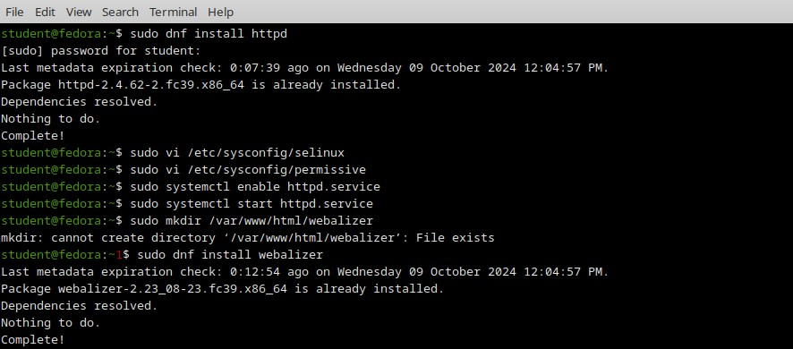

Step 6: Copy files from /var/www/usage to /var/www/html cp -r /var/www/usage /var/www/html



Step 7: Open /etc/webalizer.conf file and add the following- vi /etc/webalizer.conf

#add the following lines

LogFile /var/log/httpd/access_log #This is enabled in newer versions of fedora

LogType clf

Hostname localhost #For this one you can remove comment denoted by '#' OutputDir /var/www/html/webalizer

Step 8: Save it and then run webalizer



Step 9: Open in web browser <http://localhost/webalizer>

Open in browser http://localhost/webalizer

Click Oct.2023 link to get the report for this month

**OUTPUT:**

**Monthly statistics**

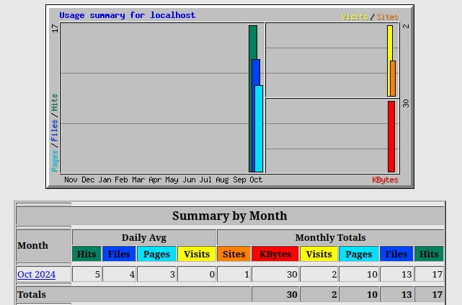

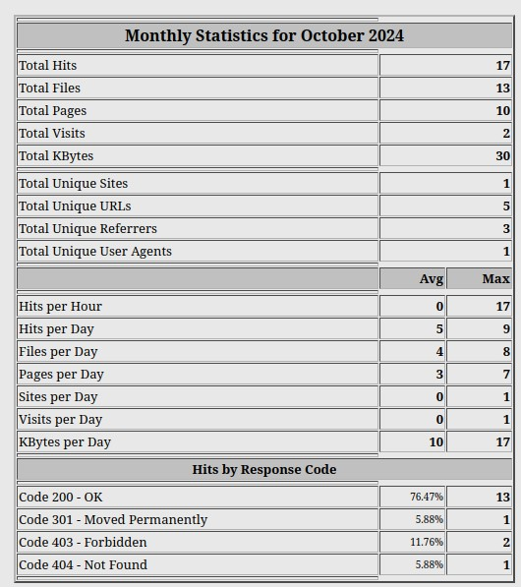**Hosts**

**Hourly usage**

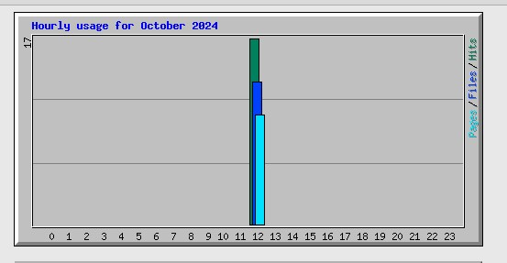

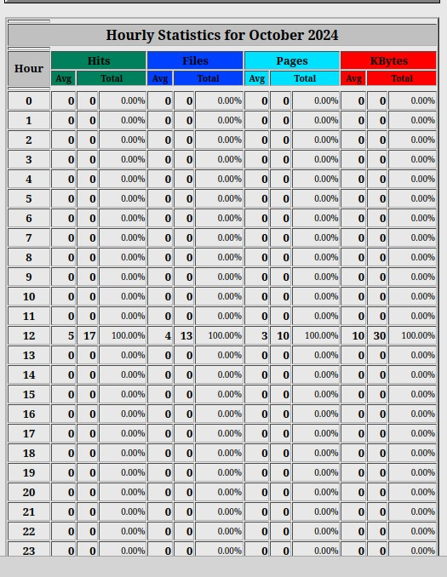

**Result:**

Thus we successfully analyze the different types of web logs using Webalizer tool.